Exercise 7: Financial Forecasting

Recursive Algorithms
- Recursion is a method where a function calls itself to solve smaller sub-problems of the same type.
- Simplifies problems that have repeated patterns or can be broken down into smaller instances.
- Needs a base case to stop recursion, or it will run infinitely.
Output
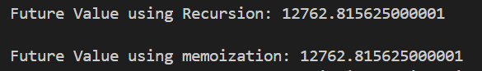
Time Complexity
- Recursive Version: O(n) (each year calls one more recursive step).
- Memoized Version: O(n), but avoids redundant calculations.
Optimization Tips
- Recursion can be inefficient if it recalculates the same results multiple times.
- Memoization stores previous results to avoid repeated computation.

